Table: Structure of LJSE turnover by type of investors (Prime Market)
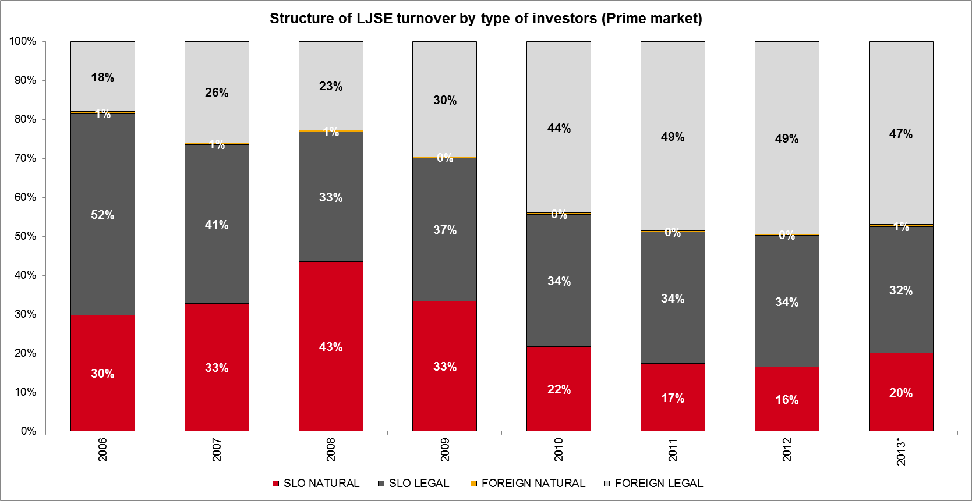
Source: LJSE, Slovene Central Securities Clearing Corporation.

