Zagreb, 24 May 2016

Joint Ljubljana and Zagreb Stock Exchanges' Investor Day

Today the third joint Ljubljana and Zagreb Stock Exchanges’ Investor Day is being held in Zagreb. This year’s Conference is the most successful one to date, as the interest of investors for meetings with participating listed companies rose by 25% compared to last year. Moreover, also the number of participating international investors is much higher than last year.

Seven Slovenian and six Croatian listed companies of the highest quality are participating in the Conference: Atlantic Grupa, Intereuropa, Gorenje, Hrvatski Telekom, Krka, Luka Koper, Luka Rijeka, Petrol, Podravka, Pozavarovalnica Sava, Tankerska Next Generation, Zavarovalnica Triglav and Valamar Riviera.

The event is being attended by 28 investment companies and banks and 55 analysts and investors from Hungary, Czech Republic, Estonia, the USA, Croatia and Slovenia. There were record 186 requests for meetings and the companies will hold as many as 160 individual and group meetings.

For this occasion Mrs. Ivana Gažić, President of the Management Board of the Zagreb Stock Exchange, stated, “We are very pleased that this joint investment conference grew into a respectable event that underscores the significance of the mutual presentation of Croatian and Slovenian capital markets. Every year, we note the increasing interest of the participants, especially foreign, which these years make a quarter of the total number of investors. We hope that this large number of meetings realized in just one day will bring some new quality investment projects to both markets.”

Mr Andrej Šketa, President of the Management Board of the Ljubljana Stock Exchange further added, “Growing interest of investors confirms that the region has a potential for growth and that interest in investing in the region is considerable, which represents a great opportunity for other companies to finance growth and investment projects through the capital market.”

The Zagreb and Ljubljana Stock Exchanges will continue with individual and joint activities to increase investors’ interest and to further strengthen the existing trust of local as well as international investors.

PARTICIPATING COMPANIES:
Ljubjanska borza | Gorenje, Intereuropa, Krka, Luka Koper, Petrol, Pozavarovalnica Sava, Zavarovalnica Triglav
Zagrebška borza | Atlantic Grupa, Hrvatski telekom, Luka Rijeka, Podravka, Tankerska Next Generation, Valamar Riviera

Contacts :
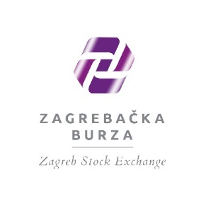 | 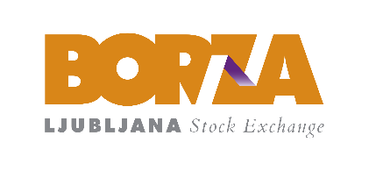
Sanda Kuhtic Nalis  Head of Corporate Communications  Ivana Lucica 2a | 10 000 Zagreb | Croatia  sanda.kuhtic@zse.hr  T +385 1 4686 804 | F +385 1 4677 680  www.zse.hr | Metka Šipek  Head, Management Board Cabinet  Slovenska 56 | 1000 Ljubljana | Slovenia  metka.sipek@ljse.si  T +386 1 471 02 21 | F +386 1 471 02 13  www.ljse.si

