Ljubljana, 25 February 2013

Positive Trends on the Slovene Capital Market: Slovene Equities Attractive to International Investors

Equities of Slovene companies are becoming more and more attractive to international investors, who reached a 67% share in the total Prime Market equity turnover on the buy side. Year 2012 was also marked by positive development in other areas:
- According to the most current data from LJSE and Central Securities Corporation, in 2012 international investors reached the highest share in the total Prime Market equity turnover so far. Their share, which till 2010 had never exceeded 30%, reached almost 50% of total Prime Market equity turnover in 2011 and 2012; on buy-side the share was even higher, reaching 67%.
- A sizeable share of international investors’ turnover was realised through Slovene brokers, who had a 74% market share.
- The share of remote members in the turnover is increasing noticeably, jumping from a 0 to 16% share in the last two years.
- Among financial intermediaries Alta Invest led with a 22% share in the total turnover in 2012.
- After two years of negative yield the LJSE blue chip index SBI TOP was up 7.8% in 2012.
- The most traded equity on LJSE in 2012 was pharmacist Krka (KRKG) from the Prime Market, which generated 46.6% of all equity transactions.
- In 2012 the Ljubljana Stock Exchange market offered a more varied range of investment opportunities and possibilities of non-bank financing, as commercial papers were listed on the LJSE market in the total amount of EUR 124.3 million.

Trends show that LJSE is becoming an international market, as ever more turnover is realised by international investors. They had the biggest share in the equity turnover of the most prominent listed companies in the last three years, which amounted to almost 50% of total Prime Market equity turnover. The share of Slovene institutional investors remained stable at 37%, whereas the most substantial decrease in turnover share can be seen in Slovene natural persons, which has halved in the last three years, amounting to only 16% in 2012. According to the number of transactions, however, natural persons led with a 55% share in all transactions, which were relatively low in value.

Changes in turnover structure reflect changes in the investment culture of retail and institutional investors. Andrej Šketa, President of the LJSE Management Board, stresses that according to investor structure LJSE is becoming increasingly more comparable to developed capital markets. “We strive to cater the needs of Slovene companies on the market in Ljubljana regardless of where investors come from.” LJSE activities in the last three years, such as Xetra trading system introduction and thus direct access of international financial intermediaries to trading, and continuous promotion of the most prominent Prime Market companies, who regularly hold presentations on investment conferences, thereby ensuring visibility with investors, have undoubtedly contributed to these positive trends. Last year Prime Market companies held as many as 228 one-on-one meetings with interested local and international investors on two investment events in Ljubljana. They also participated in promotional events abroad, which were organized by LJSE members.

In 2013 turnover is 38% higher than in the same period last year; however, significant fluctuations in the prices of equities included in SBI TOP index can be observed. Especially encouraging is also the fact that the interest of international investors in equities of Slovene companies continues to progress, as their share in LJSE equity market capitalisation is steadily increasing, amounting to 14.19% at the end of January 2013.

Table: Structure of LJSE turnover by type of investors (Prime Market)
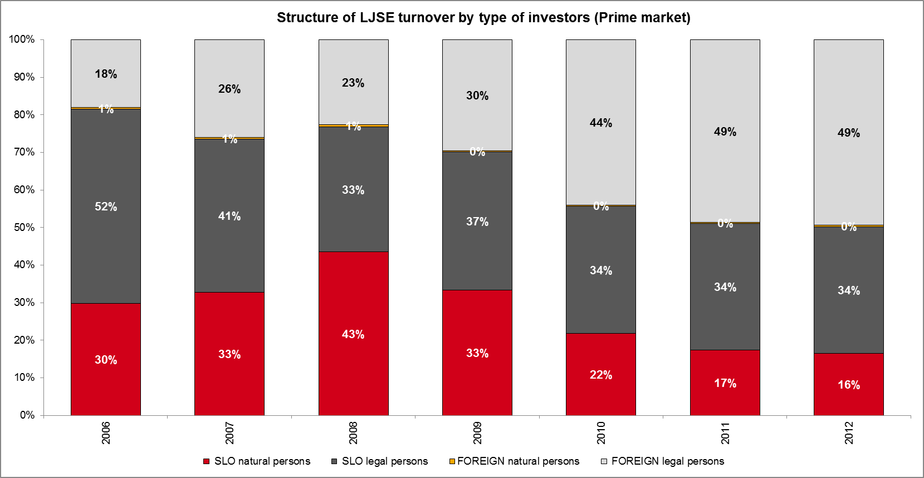
Source: LJSE, Slovene Central Securities Clearing Corporation.

Table: Share of international investors in LJSE equity market capitalisation from 31 January 2012 to 31 January 2013

Source: LJSE

For further information, please contact:
Metka Šipek, Head
Management Board Cabinet & Public Relations
Telephone: +386 1/471 0221
E-mail: metka.sipek@ljse.si

About the Ljubljana Stock Exchange
The Ljubljana Stock Exchange is a 100% subsidiary of the CEE Stock Exchange Group (CEESEG) which also includes the stock exchanges of Budapest, Prague and Vienna. The CEE Stock Exchange Group is the largest stock exchange group in the region CEESEG simplifies access to markets and trading with the aim to increase liquidity on the local exchanges. The CEESEG stock exchanges cooperate with 12 stock exchanges in Central and Eastern Europe and are recognized throughout the world for this unique expertise.

