Velenje, Jan. 9, 2004

Opening Ceremony of Logistic Center, Polystyrene Packaging Factory,
and Plastics Production Plant (NAVIS) in Gorenje

The ceremonial opening of Logistic Center (NAVIS), Polystyrene Packaging Factory and Plastics Production Plant took place today, January 9 2004 in Gorenje, Velenje, Slovenia. The facilities were formally put into operation by the Prime Minister of the Republic of Slovenia, Mr. Anton Rop. The total value of investment in all three facilities exceeds € 50 million, and construction and installation works took less than two years. New plants employ 378 people, while state of the art technology and equipment will allow safer and more efficient operation with optimized output yields.

With the NAVIS project Gorenje is concluding the process of restructuring logistic systems in the final link of production process at Velenje location. The heart of the facility is 130 m long, 90 m wide and 40 m high rack warehouse, with storage capacity of 140,000 appliance units stacked on 21,000 systemic pallets over the area of 50,000 square meters. Flow rate of the entire system is sized to the annual production output of 4 million household appliance units, i.e. 20,000 appliances daily. The facility provides simultaneous loading of 10 trucks and 5 to 10 rail wagons. Online linkage to the business information system of Gorenje provides fast, simple and transparent management of processes. The entire project also includes the infrastructure for new traffic arrangement at the west approach to Gorenje premises.

New Plastics Production Plant taking the space of 9,650 square meters will now enable expanded production of the new refrigerator factory, which also includes new information supported warehouse for semi-products. Sophisticated injection and extrusion equipment assures increase of capacity and enhancement of quality, productivity and flexibility. Annual quantity of processed plastics is set to 8,400 ton.

New Polystyrene Packaging Factory, occupying the area of 4,750 sq. meters, is expected to reduce transport costs, provide better response in supply of packaging, improve packaging quality and consequently reduce its price. The final capacity of processed EPS is planned at 3,500 tons a year.

All facilities feature substantially improved micro climatic conditions for work, and great emphasis was placed on enhanced preventive protection regarding safety at work and fire protection.

The objective of Gorenje is to reach the position of top five manufacturers of household appliances in Europe, which among other things requires innovation in development of new products, and maintaining price competitiveness. This is not possible to achieve without extensive investment. The three successfully completed investment projects, along with the ones planned for the future, are vital elements for the realization of set objectives.

Board of Directors
Gorenje d.d.

NEW LOGISTIC CENTER

FEATURES:
- Total area 50,000 m².
- Computer supported system assures coordination of all elements and automatic operation.
- Flow rate of the entire system is sized to accommodate production of 4 million units of household appliances a year, or 20,000 units per day.
- Possibility of simultaneous loading of 10 trucks and 5-10 rail wagons.
- Employing 116 operators in two shifts.
- Total investment in technology and building amounts to EUR 30.2 m.

REALIZATION GOALS:
- Conclusion of project for expansion of production capacity in the final link of supply chain - logistics;
- Enhanced efficiency of work and taking full advantage of single production location;
- Platform for further optimization of output logistics.

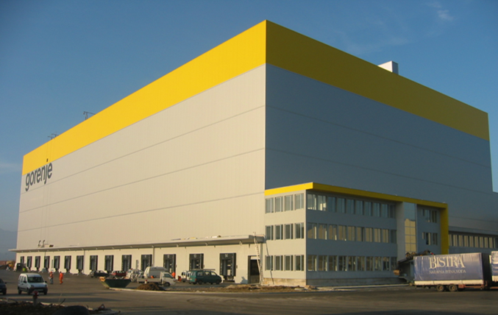 | 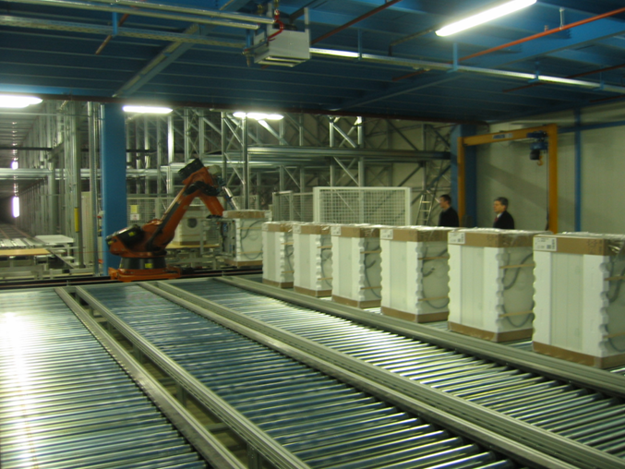

PLASTICS FACTORY
FACTORY CAPACITY:
- Production plant on 9,650 sq. meters.
- Automated extrusion, vacuuming, injection and labeling procedures.
- 2,380 pallet slots (3.5 day stock).
- Production line Refrigerator-Freezer 60%, Wet Appliances 35% and Cooking Appliances 5%.
- Annual processing capacity 8,400 tons of plastics.
- Number of operators 220, in three shifts.
- Total investment in technology and building amounts to EUR 10.09 million.

REALIZATION GOALS:
- Increase of production resulting from new refrigerator factory;
- Transfer of machinery from Refrigerator Plant related to the NG 602 Project;
- Modernization and purchase of new extrusion and injection equipment;
- Increase of capacity and enhancement of quality, productivity, flexibility and working environment quality;
- insufficient storage capacity relevant to planned production growth.

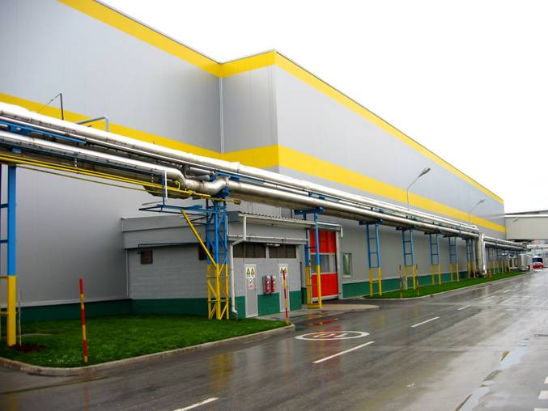 | 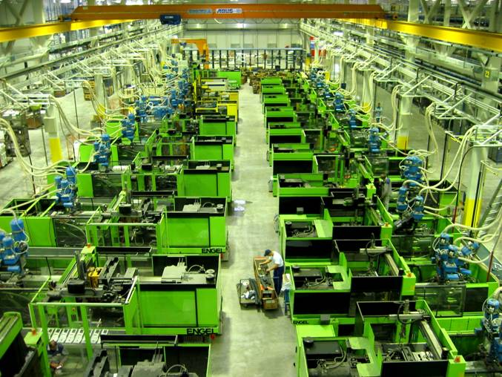
POLYSTYRENE PACKAGING FACTORY

FACTORY CAPACITY:
- Production plant on 4,750 sq. meters.
- State of the art LTH technology from German manufacturer KURTZ.
- Production entirely supported by the MES and SAP production information systems.
- Final annual capacity of processed EPS: 3,500 tons/year.
- Employing 42 operators in three shifts.
- Total investment in technology and building amounts to EUR 12.5 million.

REALIZATION GOALS:
- Increased response in packaging and wrapping supply;
- Reduced transport costs;
- Modernization of packaging and wrapping, and reduction in number of packaging items;
- Concurrent and direct transport of packaging from assembly line, without intermediate reloading;
- Less warehouse surface in factory yard;
- Cheaper package;
- Facilitated manufacture of contemporary and quality package.
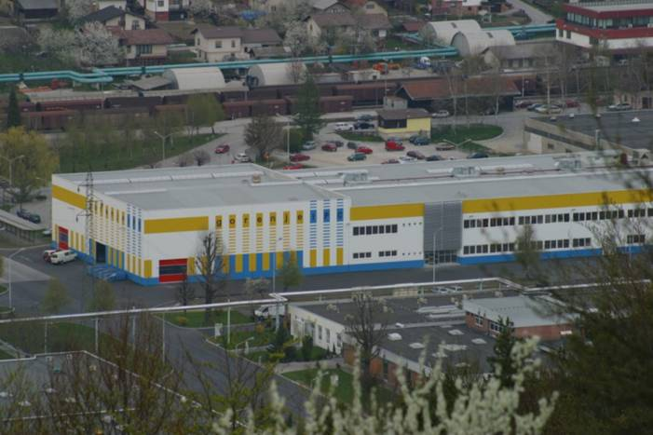 | 